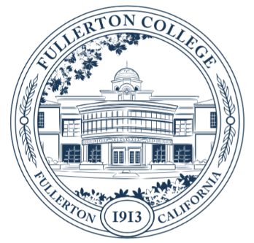

Fullerton College Program Review and Planning

Self-Study for Instructional Programs

English as a Second Language Department

Fall 2021

Statement of collaboration
The program faculty members listed below collaborated in an open and forthright dialogue to prepare this Self Study. Statements included herein accurately reflect the conclusions and opinions by consensus of the program faculty involved in the comprehensive self-study.

Participants in the self-study
Elizabeth Gaitatjis
Arthur Hui
Ellen Rosen
Jefferson Tiangco

Authorization
After the document is complete, it must be signed by the Principal Author, the Department Coordinator, and the Dean prior to submission to the Program Review and Planning Committee.

Jefferson Tiangco___________________ __Jefferson Tiangco_________ 11/15/2021
Printed name of principal author Signature Date

Jefferson Tiangco___________________ __ Jefferson Tiangco_________ 11/15/2021
Printed name of department coordinator Signature Date

Dan Willoughby____________________ _Dan Willoughby___________ 11/23/2021
Printed name of Dean Signature Date

1.0 Executive Summary
The English as a Second Language Department is proud of the achievements of our students and our program during the last four years:
- Course completion and success rates remain high and above the average of other college programs.
- AB 705-inspired changes in course placement and course sequence empowered our students to make their own decisions in their learning experience and resulted in continuously high throughput rates to transfer-level English in comparison to other Orange County community colleges.
- ESL instructors are committed to equitable practices and outcomes and continue to reflect on our pedagogy and participate in professional development opportunities to eliminate any identified achievement gaps.
- ESL courses have been a source of encouragement and motivation, particularly during the period of remote learning as our department continued to provide synchronous Zoom classes for our students, many of whom have felt isolated or have decided to temporarily leave the United States due to the uncertainty of the sociopolitical and public health situation and the rise in anti-immigrant hate and rhetoric in the country.

The ESL department has seen major changes in the population we serve, particularly after we have implemented AB 705 changes in our course sequence, class offerings, and placement process. We recognize that we have fewer ESL students coming from local high schools. Our student population now tends to be older (25+), more socioeconomically disadvantaged, women of color, and less experienced in navigating American academic institutions than a typical Fullerton College student. Therefore, our strategic action plans focus on meeting the college’s objectives of increasing outreach to and recruitment of students from underserved ESL populations (SAP #1, 2, 3, 4), removing institutional barriers to ESL student equity and success (SAP #1, 2, 3), creating a clear pathway for every ESL student (SAP #2, 3, 5), and increasing completion of courses, certificate and degree programs, and transfer readiness of ESL students (SAP #5, 6).

Finally, the ESL department calls for the college to recognize the diversity of the English language learner population in our community and that one-size-fits-all solutions to address the needs of ESL students will not support the college’s goal of cultivating a culture of equity and promoting success for every student. The role of the ESL department and our courses goes beyond language skill development. We are a lifeline for marginalized communities, and with the college’s support, we will continue to advocate for their needs and provide them with accessible educational opportunities.

2.0 Mission
Please explain briefly how your program contributes to the College’s mission, vision, core values, and goals. Highlight any new contributions since your most recent self-study. If your department has a mission statement, please share it. If not, then please consider discussing one with your colleagues.

Mission
The Fullerton College English as a Second Language Department is a highly specialized program designed to support the college’s mission by preparing students from diverse communities to fulfill their educational and career goals, whether that be through certificates, associate degrees, or transfer. Because English language skills underpin every course of study and aspect of life in the United States, the ESL sequence of courses supports students by providing flexible pathways to become successful learners, responsible leaders, and engaged community members.

Vision
Instructors in the English as a Second Language Department are committed to transforming their students’ lives not only through English language development, but also by strengthening students’ familiarity and comfort with American culture inside and outside of the academic setting. In this way, the department encourages positive change by enabling students to do well in their college studies in all disciplines and succeed as members of the world community.

ESL and Fullerton College Core Values
A number of examples will demonstrate the English as a Second Language Department’s commitment to the core values of Fullerton College.
- Students in the ESL department come from the diverse language and cultural communities that surround the college. Additionally, the department serves international students who come to Fullerton College from around the world to achieve their educational goals.
- The department continues to build upon its long tradition of excellence on campus by supporting innovation in teaching and learning.
  - In response to state and national goals for accelerated college completion, the department has implemented a streamlined pathway to transfer-level English and created a transfer-level course housed in the English department, which is taught by ESL instructors and is designed to support the language needs of ESL students. The new course sequence was designed and implemented with the involvement of students, administrators, and fulltime and adjunct faculty.
  - Additionally, the ESL department has held a number of workshops to support the professional growth of full time and adjunct faculty, many of whom have also participated in the Teaching and Learning Certificate program, the Online Teaching Certificate program, and various other professional development opportunities in light of the switch to remote learning due to the pandemic.
  - During the pandemic, the ESL Department has remained devoted to serving their students by maintaining an active connection to students through Zoom, by converting a general arranged hour requirement to a class-specific lab hour designed by individual instructors, and by seizing the opportunity to use Canvas and Zoom as effectively as possible to deliver instruction, to challenge students to continue their learning, and to promote interaction and community among students during this period of isolation.
  - Integrity and honesty are important components of ESL coursework as students are introduced, sometimes for the first time, to standards of academic honesty and taught how to avoid plagiarism through lessons on paraphrasing, summarizing, and the use of source materials.
- the ESL Departments at Fullerton College and NOCE are working together to develop pathways for ESL students to bridge the gap from non-credit to credit courses.

College Goals
The English as a Second Language Department actively supports the college’s goals.
- To promote success for every student, the ESL department aims to provide ESL learners with the language and critical thinking skills they need to succeed in all disciplines. The department is continually striving to improve its program by redesigning curriculum to create a clear pathway for every student and increase the completion of courses. More recently, the department has created a transfer-level college writing course specifically designed for ESL students (ENGL 110 F) and is currently in the process of revising advanced ESL courses to satisfy the Humanities general education requirement for an associate degree or transfer. This can reduce the amount of time ESL students need to fulfill their course requirements for an associate degree or transfer to a university. In addition, just prior to the pandemic we created an innovative one-unit course, ESL 010 F, designed to teach students how to use technology to enhance their language learning. Many students were aided by this course during the switch to remote instruction.
- To cultivate a culture of equity and strengthen connections with our community, one of the primary objectives of the ESL department is to increase outreach to and recruitment of English language learner students in the community. The department continues its partnership with North Orange Continuing Education (NOCE) by participating in collaborative projects, such as the Adult Education Block Grant and Course Alignment Project (CAEP) facilitating a smooth transition for NOCE non-credit students to the credit program at Fullerton College and identifying and removing institutional barriers to student equity and success. ESL classes are designed not only to develop students’ academic language skills but also to foster a sense of belonging where all are welcomed and student basic needs are addressed. For many ESL students, ESL classes are safe spaces to express their ideas without the fear and anxiety of being judged because of their language abilities, race, or ethnocultural background. ESL faculty members regularly encourage students to form learning communities in and out of the classroom, attend campus events, and utilize campus resources such as the Writing Center, Tutoring Center, EOPS, Counseling, and Transfer Centers. The department also maintains a strong relationship with the California State University, Fullerton TESOL Program by inviting graduate students to observe ESL classes and often hiring graduate students to work as embedded tutors through the Hornets Tutoring Program. The ESL Department has also participated in campus-wide events such as High School Family Night, Smart Start Saturday, Worldfest, Bienvenidos, and Major2Career Job Fair.
- To commit to accountability and continuous quality improvement, ESL faculty regularly participate in professional and career development opportunities both on and off campus. Faculty regularly participate in campus FLEX Day workshops, and many have reflected on their classroom policies and made efforts to apply equitable practices learned from recent professional development opportunities. In addition, several ESL instructors have completed the Online Teaching Certificate program or equivalent, particularly during the period of remote instruction due to Covid-19 restrictions. The department has also held several “Sandbox” workshops, where individual faculty can share pedagogical techniques that support high quality teaching and learning in the online environment.

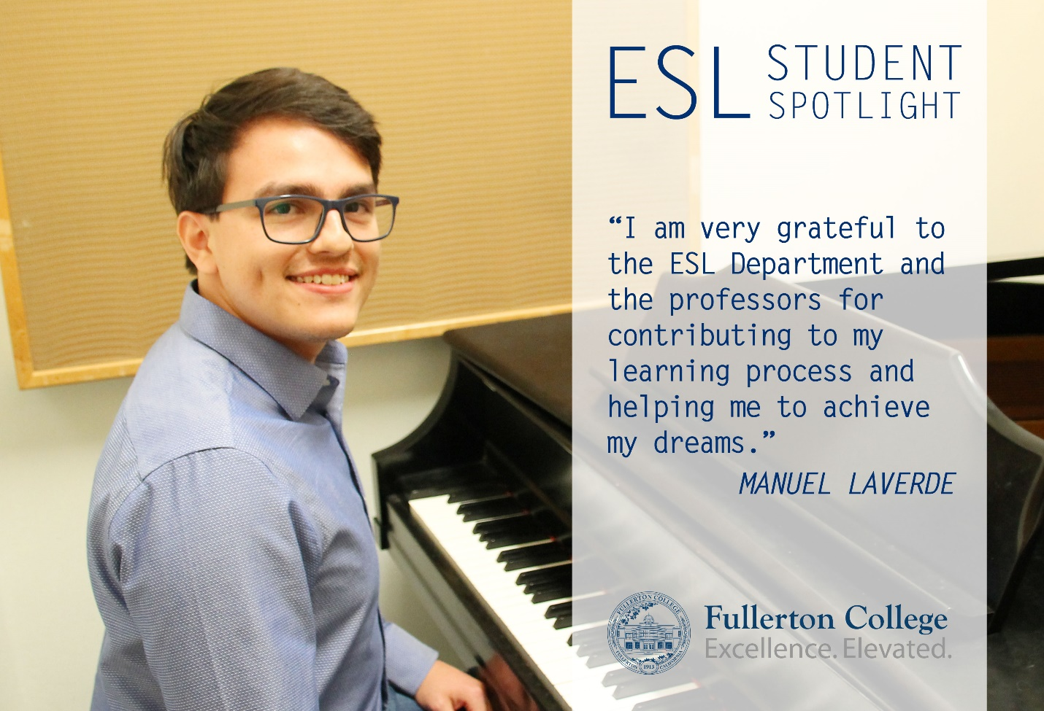

3.0 Students
Because there is a nearly infinite amount of student data that can be studied, please focus your analysis on the trends that stand out. The Office of Institutional Effectiveness (OIE) is providing data that will help you zero in on bottlenecks, gateways, and student equity issues. As per accreditation standards, OIE data will be broken down by race, ethnicity, gender, and other demographic categories. One of the purposes of this section is to identify inequities and make plans to remedy them.

Enrollment demographics
1. Using the data provided by the OIE, briefly describe the enrollment trends in the program over the past five years.

Over the past 5 years, the ESL department has experienced a 55% decline in enrollment and a 56.9% decline in headcount (Appendix A, p. 2). While these numbers are alarming, it should be noted that these numbers do not include the six sections of ENGL 101 F for ESL, which have been added (two sections in the academic year 2019-20 and four sections in 2020-21) as a pilot for ENGL 110 F, Enhanced College Writing for Non-Native Speakers, which was offered for the first time in Fall 2021.

Some of the contributing factors to this overall drop in enrollment are as follows:
- AB 705-inspired changes in our program sequence to reduce levels, including combining our 3 lowest levels (ESL 80 F, ESL 81 F, ESL 82 F) into one semester (ESL 76 F, ESL 78 F) in 2016-2017 and offering an accelerated advanced course (ESL 190 F) which students could take instead of ESL 185 F and ESL 186 F.
- an overall decline in the number of international students due to travel bans, the uncertain political situation, socioeconomic factors, and more recently Covid-19 restrictions (see Appendix C: FTES Generation Resident vs. Non-Resident).

The implementation of AB 705 has further impacted enrollment in several ways:
- The English department stopped requiring a placement test as of Oct 2018 and opened ENGL 100 F and 101 F to all students, so students can opt out of ESL classes at any time.
- All entering students with high school transcripts, regardless of language background, are strongly encouraged to register for ENGL 100 F or 101 F.
- The ESL department added a guided self-placement instrument in addition to the placement test; because students may register for the higher of the two placement results, this allows students the option to enter the program at a higher level than they test into.
- The ESL 185 F/ESL 186 F two-semester option is no longer offered as of 2018-19.

Over the past year, the ESL Department experienced a 32.3% decline in enrollment and a 32.6 decline in headcount. There are two main factors at work here. One is that we stopped offering ESL 185 F and ESL 186 F during that time. However, the main reason is the pandemic, which had a huge effect on ESL students. Not only was the move from face-to-face classes to online/remote classes very difficult for ESL students, but there was a lot of turmoil in society due to Covid-19. Many of our immigrant students, who are older than most college students, experienced job insecurity or suddenly had to take care of children who could not attend school. A number of international students left the U.S. and returned to their home countries.

2. Using the data provided by the OIE, describe the student population the department serves. Do you have a way of determining which students are majors, for example through a gateway course? Please explain.

We serve students from all ages, races, ethnicities, and income levels (see Appendix A, p. 6).
- We serve a significantly larger percentage of Asian students: 43% compared to 11.1% for the college as a whole; Latinx students make up 32.9% of our students compared to 57.8% for the college as a whole. This is not surprising, as many Asian students come directly from overseas and need language support, while many Latinx students come from local high schools and may not need ESL classes.
- Our students are older than the college average: 67% of our ESL students are over 25 compared to 26% for the college as a whole.
- We have more low-income students: 84% compared to 74% for the college as a whole.
- ESL has a lower percentage of transfer students (51% compared to 77%) largely because many of our students already have degrees from other countries or are older students whose primary goal is to improve their English skills.
- ESL has a higher percentage of students who enroll in 3+ program courses/year (21% compared to 7%). This is because many ESL students take language support courses in addition to core academic reading and writing courses in order to improve their English as quickly as possible.
- ESL has a significantly higher percentage of female to male students. The difference is 40% compared to 10% for the college as a whole. We do not have an explanation for this surprising difference.

ESL does not offer a major, so all our students are “non-majors.” We do not have a “gateway course” for our program, but our highest courses (ESL 190 F and ENGL 110 F) can be considered gateway courses for all other academic programs.

3. Which classes have the highest demand and why? Are they offered regularly -- at different times of the day and week, in different formats (in-person, on-line, hybrid)? Please explain.

Our two advanced levels, ESL 184 F and ESL 190 F, have the highest demand. This is true for several reasons:
- Many newer and younger students have stronger English skills and enter at a higher level.
- Students who start at intermediate level continue to advanced levels, joining newer students who begin at the advanced levels, creating a swell in enrollment.
- Fullerton College’s policy is that International Students must enter the program and be placed at ESL 184 F or higher. Our program is not considered a full-time/intensive language program for F-1 visa purposes.
- ESL 190 F feeds into transfer-level English, which is required for transfer, so this course is in high demand.
- Potential ENGL 110 F students may opt instead to take ENGL 100 F or 101 F, both of which offer dozens of sections that may fit better with their schedules, whereas we are currently only able to offer 1-2 sections of ENGL 110 F.

Both ESL 184 F and 190 F have been offered every semester, both in the daytime and in the evening. In alternating semesters, we offer these courses at different times of the day and on different days of the week to accommodate different students’ schedules. The ESL department believes that the in-person format is superior pedagogically to online or hybrid courses for these courses, so we have not offered either of these courses in an asynchronous online or hybrid format.
4. Please describe how course offerings match students’ preparation and goals.
For the past two academic years, based on the recommendation of AB 705, the ESL Department has offered sections of ENGL 101 F for ESL students. These sections, designated exclusively for non-native speakers, allow ESL students to enter or continue their studies at the transfer level with additional language support and added confidence. Beginning in Fall 2021, this course will be called ENGL 110 F. This course will be taught by ESL faculty and has been fully approved for IGETC 1A and CSU A2 transfer requirements and the local Associate Degree A1 requirement. It is equivalent to ENGL 100 F and ENGL 101 F.

To further match our program to students’ preparation, the ESL Department has created and implemented a Guided Self-Placement Assessment for entering students. Replacing the standardized test with guided self-placement makes it easier for students to place themselves based on their actual preparation and goals rather than their level of English proficiency as judged by a test.
In addition, transfer level English classes (ENGL 100 F and 101 F) are now open to all students, so students have the option of taking transfer level English at any time. They are not forcibly “held back” in ESL. Furthermore, we offer pop-up exams each semester which give students the possibility of skipping levels within our program.

5. Does enrollment vary by semester? Please describe how course offerings are adjusted to meet student demand and help students reach their academic goals.
Our priority is to offer ALL core courses with both morning and evening sections. Our Spring enrollment is usually slightly less in Fall, but the larger issue has been the plummeting enrollment numbers, and how to keep all our core courses available in both daytime and evening.
For our lowest enrolled courses, ESL 76 F and ESL 78 F, we have had to alternate between 76 F and 78 F in the evenings in Fall and Spring semesters. During the Covid-19 year (2019/20), we had to drastically reduce our course offerings. As a result, we were only able to offer 76 F/78 F in the mornings. This has impacted enrollment at the next level. Beginning in Fall 2021, ESL 82 F replaces 76 F/78 F in our course sequence, reducing the number of courses intermediate level students have to take. We are also relying on innovative means to offer these courses both in the morning and evening by using a cross-listed hybrid format. Furthermore, while we would like to offer support courses (i.e. grammar, pronunciation, vocabulary) in the evening, these have historically been low-enrolled. Our solution is to begin offering one asynchronous support course each semester.

Student Achievement and Equity (and student demographic profile)?
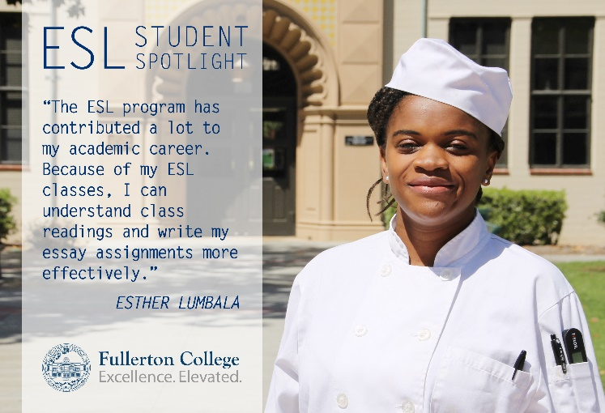
1. Using the data provided by the OIE, briefly describe student achievement rates in your program over the past five years: completion, success, degrees/certificates, transfer, licensing, job placement, wage improvements (not all of these measures apply to every program).
Our course completion rate has consistently ranked above the average of all other Fullerton College programs. It is not a surprise that the completion rate dropped during the semester when all classes switched over to Zoom, but it is a surprise that it rose during 2020/2021 despite remaining fully online. We attribute this to our efforts to adapt to the new Zoom environment, to ease the transition for students, and to incorporate the weekly arranged lab hour into our class time. The fact that we kept all our classes synchronous on Zoom was a huge help for most of our students, many of whom relied on our classes for encouragement, connection, and support during this period of isolation.
Our course success rate, already well above the average of all other Fullerton College programs (about 10 percentage points above the average of other programs, Appendix A, p. 10), also rose significantly during the 2020/2021 academic year. We attribute this to several factors. The main one is that the requirement that students pass at least one of three timed in-class writing exams (without the use of any electronic devices) had to be dropped. Other factors include our increased emphasis on grading for equity: not penalizing late assignments and focusing on assessing performance rather than behavior/study habits.
2. Please pay special attention to equity issues -- where a group of students has an achievement rate that is below average. What factors can explain this?
According to the OIE data provided (Appendix A, p. 15), there was no equity gap for course completion across gender and race. The two gaps that were identified were in course success by gender and course success for DSS students. The course success for males over the past 5 years has been 75.6% compared to 82.3% for females. When we disaggregated by race, we found that the success rates between male and female Latinx students have switched several times in the past 5 years. For Asian students, females have done better consistently, although the males caught up in the last academic year (see Appendix C: ESL Course Success - Latinx and Asian).
We want to know more about the DSS data but have been unable to determine if particular disabilities have less equitable outcomes compared to others. We are aware that deaf students in particular have struggled in our classes in the past. Deafness makes the four skills of language learning (reading, writing, speaking, listening) very complex. Moreover, sign languages can vary across different language cultures adding to the complexity of the learning experience for our deaf ESL students. Faculty would benefit by having more training in this area.

3. Does the department have regular discussions about equitable grading, attendance, late-work, and extra credit policies, or about other strategies for helping students succeed? Could reforming classroom policies help more students succeed? Please explain.
In our Fall 2020 program review update, we identified a discrepancy in success rates for males and Latinx students, in particular, Latino males. We discussed this in detail when we wrote the update, including ideas for how to bridge this gap. Since the last program review update, we have initiated several actions:
  - Individual faculty have completed professional development workshops on equitable grading.
  - We created “Sandbox” workshops to improve our Zoom/Canvas teaching skills; one of these workshops was a joint meeting with ESL full and part-time faculty, embedded tutors, and Hornets Tutoring staff to discuss ways of promoting tutoring and engaging students.
  - We began offering a new course, ESL 10 F, a one-unit course designed to improve basic technology skills for college students—just in time for the pandemic.
  - We continue to promote the writing center and conversation partners.
  - We use Canvas technology to notify students of due dates and missing assignments.

4. Please write a brief Equity Action Plan. What strategies can you implement to close this gap in student achievement within the next five years? What professional learning, curriculum development, or other forms of support does your department need?
The ESL Department is committed to continue addressing any identified student achievement gap through the following strategies:
- The department faculty, full-time and part-time, will have continued dialogue on equitable grading and class polices and continue to participate in related professional development opportunities.
- The current course revisions for ESL 184 and ESL 190 include more relatable cultural components for non-native speakers of English with course content and recommended textbooks and readings highlighting the experiences of immigrants, English language learners, and other minority groups.
- All ESL full-time faculty and some part-time faculty are volunteering to be a part of the Starfish pilot, a program that supports student success, retention, and completion by building community and facilitating improved communication between students, faculty, and campus services.

3.3 Student Achievement and Pathways
1. Using the data provided by the OIE, briefly describe how students have moved through the program over the past five years: unit accumulation, prerequisites, corequisites, substitutions, gateway courses, and bottleneck courses. (Not all of these measures apply to every program.)
While the 5-year data from OIE (Appendix A, p. 18) shows a 10 - 15% withdraw rate and about 4.4% - 8.4% of students repeat a course in the top 5 most enrolled courses in ESL, the data from the California Community Colleges Transfer Level Gateway Completion Dashboard shows a much clearer picture of ESL throughput. Fullerton College ESL students’ transfer-level completion rates within a 3-year completion timeline as prescribed by AB 705 from 2017 to 2020 consistently indicate a pattern a success rates well above the average of other Orange County community colleges over the last 3 years (Appendix C: Transfer Level Completion Rates in ESL for Colleges in Orange County). With AB 705 inspired changes in our curriculum and course sequence, the path to transfer-level English for an ESL student in the sequence is much shorter and course content not only includes academic English language building skills but also college success strategies and embedded support services from tutors and the WALH Skills Center, which improves course retention and success and encourages course sequence completion. In addition, ESL students can make the decision to take transfer-level English (ENGL 100 F or ENGL 101 F) at any point in the ESL sequence, which may also contribute to the higher throughput numbers. These changes in the ESL department and the English department have empowered students to make their own decisions in their academic career, and faculty have provided encouragement, support, and advise as needed.

2. For transfer degree programs: Are your current requirements in line with the Transfer Model Curriculum, or have you added extra steps, such as prerequisites? If you added extra steps, please explain.

The ESL department does not have a transfer degree program.

3. Please provide an update on the curriculum mapping you have done, perhaps in collaboration with Counseling. Are all programs (degrees and certificates) mapped? Based on course offerings for the last two to three years, could a student complete the map(s) you have created? If so, please demonstrate this with some facts from your schedules. If not, how will you address these discrepancies?
4. Do the data reveal differences among your AA, ADT, or certificate programs (in enrollment, completion, or success, for example)? Please explain.

The ESL department does not have program degrees and certificates.

Faculty
1. Using the data provided by the OIE, briefly describe the faculty workload over the past five years: FTF (full-time faculty), PTF (part-time, or “adjunct” faculty), FTEF (full-time equivalent faculty), WSCH per FTEF (weekly student contact hours). (Not all of these measures apply to every program.)
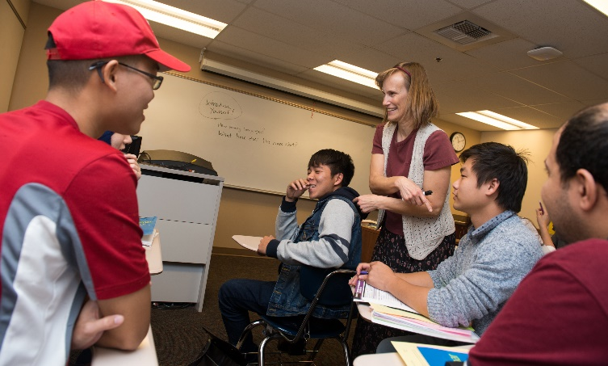
As enrollments and number of sections declined during the last five years, the sections taught by full-time faculty increased reaching a 70% FT to 30% PT ratio by academic year 2019/20. In the following academic year, two full-time faculty members retired changing the ratio to 64% FT to 36% PT.

Prior to the major changes brought on by AB 705, fill rates were stable at around 80% but started to decline to less than 70% by academic year 2020/21. In order to promote student success and provide pathways to completion, the ESL program is committed to provide a complete program offering at least one day section and one night section of each course level in the ESL sequence every semester. With decreasing enrollment, fill rates are bound to be less than it used to be. The shift to remote learning during the pandemic further decreased the department’s average fill rates. In addition, our students, who tend to be older, lower income, and take several courses, require more flexibility in the way classes are scheduled. We offer a robust selection of language support courses not only to provide students opportunities to accelerate their language development but also give students opportunities to fill a full-time course load to satisfy financial aid and other special program requirements.

2. If your department plans to request hiring a full-time faculty member, this is the place to make the argument. Please discuss hiring needs in reference to data analyzed in sections 3.1 to 3.4.
With the continuous decline in enrollment and the uncertainty of what the ESL program will look like after the pandemic and the gradual return to in-person classes, the ESL department is not planning to hire a full-time faculty member during the next program review cycle.

3.5 Covid-19
Using the data provided by the OIE, briefly describe how the Covid-19 pandemic affected your department and how your department has adjusted. Did you make temporary changes? Or have you adopted new, long-lasting practices that enhance teaching?

The most significant effect of the pandemic on the ESL department is the decrease in enrollment. Even though enrollment numbers were already declining prior to the pandemic, it is also clear that transitioning to remote learning during the academic year 2020-21 saw the greatest decrease at -32.3%.

Both students and faculty were challenged by the lack of access to good tech equipment, reliable internet services, and a private space during Zoom classes. Formative and summative assessment of language skills also proved to be difficult, particularly with timed in-class writing exams, which is an important course objective in core academic reading and writing ESL courses.

Another major challenge during the pandemic is shifting the one hour arranged lab in the Skills Center in core ESL courses as part of the regularly scheduled class time. This created a six-hour-a-week class schedule, which may have been another deciding factor for some students not to register for classes during the pandemic. In addition, the Skills Center is an important part of the department’s efforts to build a learning community where students get to interact with each other outside of the regularly scheduled class time and have more opportunities to develop their language skills and meet new people.

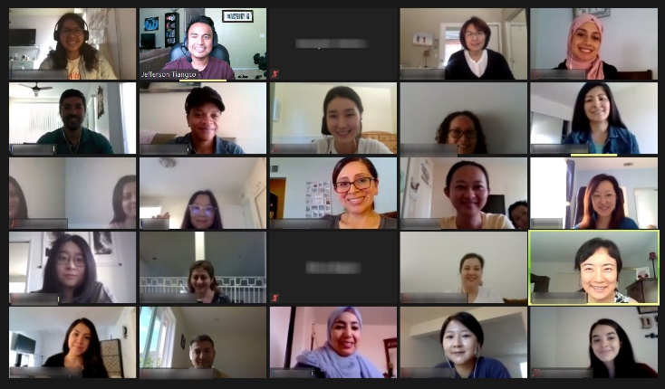
The pandemic, however, has also brought opportunities. With synchronous classes through Zoom, the ESL department has been able to serve students who otherwise would not have taken in-person classes due to personal responsibilities that would have prevented them from coming to campus. The fact that we kept most of our classes synchronous on Zoom was a huge help for most of our students, many of whom relied on our classes for encouragement, connection, and support during this period of isolation. In addition, more faculty are now OTC certified, and by attending online professional development courses and department-led “sandbox” workshops, many have learned several pedagogical techniques leveraging technology, such as tools in the LMS (Canvas), collaboration through Google Slides/Google Docs, and using free online resources (OER). The department also started offering fully asynchronous online classes (ESL 35 – Intermediate Grammar and ESL 45 – Advanced Grammar) during the pandemic. Finally, with the pandemic affecting many aspects of our students lives, faculty have reflected on grading and attendance policies and made efforts to apply equitable practices learned from recent professional development opportunities.

3.6 What has not been asked?
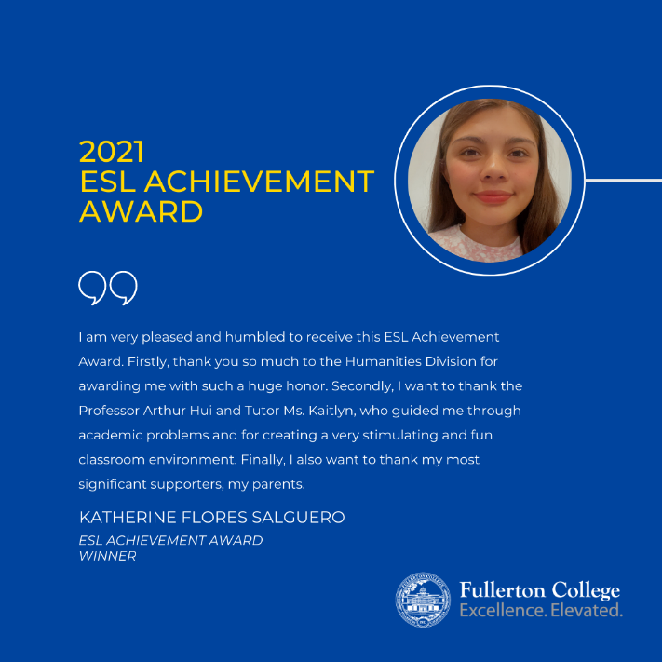
Please tell us about other ways your department has been successful, ways that the previous questions might have missed.

The ESL Department has been successful in supporting ESL students’ academic and other personal goals through the following:
- A mentoring program, designed and implemented by the FC ESL department in collaboration with North Orange Continuing Education (NOCE), was established to transition students from NOCE’s non-credit ESL program to Fullerton College. Mentors are vital in providing the guidance to college access, registration, counseling, and support not only through a transition from non-credit to credit but through an advocacy process throughout a semester—making the most under-represented and underserved students have a more equitable representation for educational opportunities. Unfortunately, this program was ended by NOCE just before the pandemic started, but the ESL department is currently looking for other opportunities to provide mentoring to ESL students.
- An embedded classroom-tutor system via FC Hornets Tutoring positively impacts learning and retention in classes. A tutor assists students to better understand course concepts through weekly sessions for collaborative opportunities for learning and also connects students with other campus support services. For the past two academic years, most ESL core courses have an assigned Hornets Tutor.
- Our department and our classes provide a safe space for multilingual English language learners from all walks of life. Many of our students experience the American college classroom for the first time in our classes, and one of the major roles ESL faculty play is being a mentor to ESL students in helping them navigate the often complicated systems and processes in college, such as registering for classes, applying for financial aid, accessing student support services, and even looking for jobs or applying for US citizenship. While there are departments at the college that provide these services, ESL students often seek advice from their ESL professors first.

4.0 Outcomes

4.1 Program Student Learning Outcomes (PSLOs)
Since the last self-studies, the College adopted new Institutional Student Learning Outcomes (ISLOs) and new design principles for PSLOs. Please describe your department’s PSLO revisions to date, and your PSLO plans.

The ESL department does not have any program-level student learning outcomes (PSLOs).

4.2 PSLO Assessment
The new PSLO design principles encourage departments to use PSLOs as a way of gauging student learning once they have completed a degree or certificate, not just when they have completed a single course. Please describe how PSLOs are assessed or will be assessed in your department.

The ESL department does not have any program-level student learning outcomes (PSLOs). The ESL program does not award degrees or certificates although the department is looking into the possibility of creating certificates in the future.

4.3 CSLO Assessment
Briefly describe the timeline your department uses to assess CSLOs on a regular basis and how you use the results to make improvements. This discussion should be based on SLO data, which is available on eLumen. (Your division’s SLO reps can help with this.) Please include relevant CSLO charts or graphs in an Appendix. Since the last self-study, you should have assessed the CSLOs of every course that you have taught, at least once. If that is not the case, please describe how you will accomplish this as soon as possible.

The ESL Department assesses all courses offered every semester (see Appendix B). When the transition to remote learning happened in Spring 2020, the department decided not to assess our courses due to the unique nature of the semester when COVID-19 restrictions started. Since then, we have started to assess our courses as we also try to adapt our assessments using online tools. We plan to continue assessing all courses every semester once we return to in-person classes in Spring 2022.

Individual instructors look at the results of their assessments and make individual adjustments. The department plans to use the Spring FLEX Days to discuss assessment results from the previous fall semester and plan any assessment or curriculum modifications as necessary.

4.4 SLO Equity Analysis
1. Looking at CSLO attainment data, do you find significant differences by race, ethnicity, gender, and other categories? Please include some illustrations of this data in the Appendix. Describe here what the data shows. What strategies will you use to close the attainment gaps among groups of students? What kinds of professional learning would help?

The data produced by eLumen disaggregating CSLO attainment data by race and ethnicity presented difficulties for the department to come up with any valid conclusions about any attainment gaps by race and ethnicity. CSLO attainment rates vary by course type (core academic reading/writing or language support), course level (intermediate or advanced), and academic year.

To exemplify, we looked at CSLO attainment of our two largest ethnicity groups, Asian and Hispanic, in our top course in the intermediate levels (ESL 83) and our top course in the advanced levels (ESL 190) (see Appendix B). We do not see any significant differences between Asian and Hispanic ESL students in ESL 83’s CSLO attainment. In ESL 190, there is a slight difference in one of the CSLOs related to reading comprehension, where Hispanic students outperform Asian students. Some ideas that could explain this is how Hispanic students tend to do better in reading advanced level texts due to the closer cross-linguistic relationship of Spanish and English as compared to English and other Asian languages. Also, before all the AB 705 changes in placement, many Hispanic students came from local high schools and may have had more experience with academic texts in English prior to taking ESL classes at Fullerton College. It must be noted, however, that eLumen provided an average attainment rate from the last five years. A trend line may provide us a better picture and help us identify any gaps among specific groups of students. Finally, the ESL department would like to encourage our campus to either improve the eLumen end-user experience or look for alternative programs to collect and analyze SLO data.

2. Compare the equity analysis in this section to the equity analysis in Section 3.2. Are there some groups who have lower completion and success rates AND lower SLO attainment rates than other groups? Can new departmental strategies close both gaps? Please explain. [For example, many departments found that their SLO attainment gaps are quite a bit smaller than their success gaps (or the gaps don’t exist). This might mean that many students who get a D or lower in a course are actually learning the material (i.e. attaining the SLOs) but they are winding up with a failing grade for other reasons: absences, tardies, missed assignments, missed exams, poor performance on high-stakes assignments.]

Regardless of CSLO attainment rates, course success rates in ESL classes remain high. While CSLOs help the department identify whether students have mastered discrete language skills important to the course level, passing an ESL course involves a more wholistic assessment of different language skills and academic preparation. This can be seen in the example in ESL 83 (Appendix B) wherein students may not be attaining mastery of verb tenses (below 60%) but are performing well in reading comprehension of intermediate-level passages (80%) and writing multi-pointed paragraphs (above 80%). To compare, the average course success rate of ESL 83 students from the last five academic years is around 76%, just above the average of all three SLO rates.

5.0 Other Areas of Program Effectiveness

5.1 Your Department and General Education
- Using the data provided by the OIE, please look at students who take your courses for GE credit.
- What role does your department play in helping students complete the GE pathway?
- Do you offer GE courses at a variety of time slots and at a frequency that allows students to fulfill GE requirements?
- Please take into account daytime, evening, weekend, and online classes to provide a brief sketch of your GE course availability.

Starting Fall 2021, English 110 F (Enhanced College Writing for Non-Native Speakers) has been approved for CSU/IGETC transfer and can be taken for GE credit. ESL 184 F and ESL 190 F are in the pipeline in getting approved for the Humanities GE requirement for transfer and associate degrees. English 110 F, ESL 184 F, and ESL 190 F are offered every semester for students. ESL 184 F and ESL 190 F are usually offered in both the daytime and evenings.

5.2 Outside Influences on Your Department
- Describe any laws, regulations, trends, policies, procedures, or other influences that have an impact on your program. Please include any other data that may be relevant to student achievement, learning, and trends within your Basic Skills, CTE, or Transfer Education programs.
- Make sure you are including all degree and certificate programs, including the College’s GE program.
- Please also consider not only your courses, but also prerequisite and corequisite courses that might be offered by a different department.
- If AB 705 applies to the program then how are you meeting its mandates?

There have been 3 main outside influences that have impacted our program over the past 4 years: implementation of AB 705, federal immigration policies, and COVID-19.

AB 705
Since the 2018 passage of AB 705, our population has experienced a drop in enrollment from 1,208 in 2017 to 544 in 2021, a 55% drop. This correlates with a drop in headcount of 666 in 2017 to 287 in 2021 (57% drop). As AB 705 encourages students to enroll in transfer-level English, the effects on our ESL program have been sudden and significant since many students, particularly those who come from local high schools, have opted to enroll in ENGL 100 F or 101 F instead of the ESL sequence.

In response to AB 705, the ESL department has developed a multi-lingual designated section of transfer-level English called ENGL 110 F to serve this population of students. The ESL department has also developed a guided self-placement in order to provide multiple measures for ESL students when placing into our sequence. These two features meet the mandates of AB 705.

Immigration Policies
In addition, with Executive Order 13780 signed in March 2017, students from countries such as Iran, Syria, and Sudan, were no longer allowed to enter the United States. Although the order was rescinded in January 2021, almost four years of not allowing students from these countries have negatively impacted our enrollment. Since our current Tableau data does not disaggregate by country of origin, it is difficult to know the exact extent this order has affected student population. However, it may take years for students from these countries to apply for and enroll at Fullerton College again.

With regards to the U.S. Annual Refugee Resettlement Ceilings, as recent as 2015, 70,000 refugees were allowed into the U.S. By 2020, the ceiling had dropped to 18,000 with far fewer admitted (11,814). Although the ceiling in 2021 has been raised to 62,500, only 6,246 refugees have been admitted so far this year (see Appendix C: Annual Refugee Resettlement Ceiling and Number of Refugees Admitted to the United States). This has impacted our program since our department has historically served refugee students from different countries. Current Tableau data do not account for refugee population, so it is difficult to know how many students have been affected.

COVID-19
Finally, with COVID-19, many students (resident and non-resident) traveled back to their home country for various reasons. Our department has anecdotally learned that many of these students have not returned to United States. Although COVID has impacted all enrollment, the ESL department has been disproportionately affected because the number of international students that our department serves. Many of our Asian students are international students, and the number of Asian students in 2017 was 395. In 2021, our Asian population is 129, a drop of 68% in 4 years (see Appendix C: ESL Enrollment Count, Asian).

5.3 Your Program’s Active and Applied Learning and High-Impact Practices (Department)
- The College wants to create an inventory of faculty efforts to make learning active and applied. Please briefly describe opportunities your students have to apply and deepen knowledge and skills through projects, internships, co-ops, clinical placements, group projects outside of class, service learning, study abroad, and other experiential learning activities that you intentionally embed in coursework, or elsewhere in your program.
- Are there institutional barriers hindering your department’s ability to offer or enhance these learning experiences for students? Please explain.

Although faculty consistently assign group projects as part of students’ learning, the nature of our courses does not lend themselves to internships, co-ops, clinical placements, or study abroad programs. Students in our courses focus on developing college writing skills across the curriculum and developing English conversation skills. Students are applying their learning in their ESL classes, other classes, and interaction with the overall college community since their priority is academic success and achievement utilizing English.

6.0 Planning

6.1 Progress on Previous Strategic Action Plans
1. Please briefly describe the goals (Strategic Action Plans, SAPs) from your last self-study. How much progress have you made on them? If you have reached a goal, explain how it allows ongoing improvement, especially if you received additional funding.
2. If additional funds were NOT allocated to you in the last review cycle, how did the LACK of funds have an impact on your program?

Strategic Action Plan #1
ESL Pathways video: Produce a video to explain different pathways through the ESL course sequence to current and prospective students.
The ESL department, in collaboration with the Humanities division, counseling, and assessment, created the ESL pathways video as described in the plan. It was completed in Spring 2018, and funding was provided by the former Pathways Transformative Initiative grant. The video became an important part of the onboarding process for new ESL students and is available on the ESL department’s website and the Guided Self-Placement used by assessment and counseling. Because of the recent ESL sequence changes made by the department to address AB 705 and the decline in enrollment, the video needed revisions in 2021. The department has revised the video in Fall 2021. With the help of the Humanities Division, funding has been identified to pay for the revisions.
ESL promotional video: Produce a video to inform prospective students of the benefits of ESL courses offered at Fullerton College

This video was not created. Funding was not available, and more attention and resources were given to the pathways (ESL sequence) video as this was a crucial part of the department’s efforts to address AB 705 and AB 1805
********************************

Strategic Action Plan #2
Redistribute evening hours for the Weekly Arranged Lab Hour (WALH): Extend evening hours in the WALH to allow for greater access by night students.
In Spring 2019, the department reduced morning hours and added more night hours to give students taking ESL classes in the evening more options to complete their lab requirement. No additional funding was requested for this schedule change. Unfortunately, due to the pandemic closures in Spring 2020, the department was not able to gather sufficient data to evaluate whether the change in the schedule met the plan’s objectives of increasing access to night students. The ESL department believes that the WALH is an integral part of student success and is one of the strengths of the ESL program. The department is planning to reopen the Skills Center lab in person in Spring 2022 and will offer a schedule that will accommodate morning and night students.

********************************

Strategic Action Plan #3
Streamline transfer of ESL students from non-credit to credit ESL program: Align North Orange Continuing Education ESL courses with Fullerton College ESL courses to allow NOCE ESL students to transfer to Fullerton College without taking the ESL assessment test.
Between 2019 and 2021, a workgroup comprised of ESL faculty from Fullerton College, Cypress College and NOCE collaborated on aligning non-credit ESL classes at NOCE with credit ESL classes at Fullerton College and Cypress College and establishing a more streamlined process to transition from non-credit to credit. The workgroup identified, however, that course alignment is not advisable due to particular articulation challenges and the different in-take processes in each institution. Additionally, transition from non-credit to credit is not always a straight line as many students concurrently enrolls in both non-credit and credit classes in any given term. The workgroup also identified barriers that students face when they decide to take credit ESL classes, which include navigating the matriculation process and reaching off-site non-credit ESL students. The workgroup recommends that ESL departments from all 3 institutions should collaborate on doing more targeted outreach events for NOCE ESL students and expand and improve counseling services in both the non-credit and credit side.

6.2 New Strategic Action Plans
Please write brief, concrete plans that you will accomplish over the next four years. Your plans might include requests for additional funds. The Program Review Committee will read these and either endorse the request or ask for more information. Please keep in mind that the Committee’s endorsement does not guarantee additional funding. The President’s Advisory Council and Faulty Allocation Committee play major roles in allocating funds and prioritizing new faculty hires.

Please number each of your plans. This will help keep to track of them. Also, make sure that each funding request includes the following elements:
- It is supported by the data and analysis in previous sections of this self-study.
- It fulfills a part of the College mission, vision, goals, or objectives.
- It explains how the request helps the College attain student equity.
- There is a measurable way to tell if the extra funding will be effective.
- It considers whether you can reach this goal (or parts of it) without additional funding.
- Please give a dollar amount, or best estimate. If you can identify a funding source, then please name it. If you can put the request into one of the following categories, please do so: Personnel, Facilities, Equipment, Supplies, Computer Hardware, Computer Software, Training, Other.

Strategic Action Plan (SAP) #1: ESL Department
Describe Strategic Action Plan. | Hire bilingual community outreach experts to promote the ESL program and degree and certificate completion at Fullerton College.  The ESL student population at Fullerton College is changing post AB 705. We have fewer ESL students from local high schools. ESL students tend to be older (25+), more socioeconomically disadvantaged, women of color, and less experienced in navigating American academic institutions than a typical Fullerton College student. Our target population lives and works in our community but is more dispersed. Some have been living in ethnic enclaves for a long time, while others are recent immigrants and refugees still learning to navigate American society and access social support services and educational opportunities. Many of them may think that going to college to pursue a degree or certificate is a risk and may not be aware of all the financial and academic support our college provides. In addition, some are intimidated by the matriculation process involved, starting from the complex application form in CCCApply to the online registration process in MyGateway.  Therefore, to support the college’s goal and objective of cultivating a culture of equity and recruiting students from underserved populations, the ESL department, in coordination with the college’s other outreach efforts, is looking to hire bilingual community outreach experts that will visit local ethnic community centers or places of worship, businesses with many immigrant workers, and other local organizations where our target population usually gathers. The outreach expert will create bilingual promotional material, make presentations, conduct college tours, and help potential students apply to the college and guide them through the onboarding process of becoming a Fullerton College ESL student.  Outreach experts can come from our current or former ESL students or other potential candidates in our college community. We are hoping to have bilingual experts in our top ethnolinguistic populations: Spanish, Korean, Vietnamese, Arabic, Chinese, and Farsi. The bilingual outreach experts will be managed and administratively supported by an ESL faculty member under a professional expert contract to ensure department and college needs and goals are met.
List College goal/objective the plan meets. | - Goal #1.1: Create a clear pathway for every student.  - Goal #2.1: Remove institutional barriers to student equity and success.  - Goal #2.3: Increase outreach to and recruitment of students from underserved populations  - Goal #2.4: Foster a sense of belonging where all are welcome and student basic needs are addressed  - Goal #3.2: Strengthen partnerships with business and community to promote a strong workforce and successful career outcomes for our students
Explain how the request helps the College attain student equity. | This request helps the college’s goal and objective of cultivating a culture of equity and increasing outreach to and recruiting students from underserved populations.
What Measurable Outcome do you anticipate for this SAP? | - Increase enrollment in ESL classes.
What specific aspects of this SAP can you accomplish without additional financial resources? | - Create a job description for the bilingual outreach experts.  - Help with the recruitment process.

If additional financial resources would be required to accomplish this SAP, please complete the section below. Keep in mind that requests for resources must follow logically from the information provided in this self-study.
Type of resource | Requested dollar amount | Potential funding source
6 Bilingual Outreach Experts  - Project Coordinator - $35/hr (Professional Expert)  - 10 hours a week for 12 weeks per year | $ 4,200 per bilingual outreach expert per academic year  $ 25,200 per academic year | Program Review Funds  Student Equity and Achievement Program (SEAP)  Federal Covid-Relief Funds  Other Equity-based Grants/Funds
ESL faculty outreach program administrator  - Technical Expert II - $55/hr (Professional Expert)  - 10 hours a week for 12 weeks per year | $ 6,600 per academic year | Program Review Funds  Student Equity and Achievement Program (SEAP)  Federal Covid-Relief Funds Other Equity-based Grants/Funds
3 loaner laptops | $ 3,000 total | Program Review Funds  Student Equity and Achievement Program (SEAP)  Federal Covid-Relief Funds Other Equity-based Grants/Funds
TOTAL requested amount | Personnel: $31,800 / year  Equipment: $3,000 | Program Review Funds  Student Equity and Achievement Program (SEAP)  Federal Covid-Relief Funds Other Equity-based Grants/Funds

Strategic Action Plan (SAP) #2: ESL Department
Describe Strategic Action Plan. | Collaborate with NOCE faculty and staff and conduct more outreach events to promote transition from non-credit to credit ESL.  As Fullerton College’s ESL student population changes post AB 705, non-credit ESL students will be one of the primary sources of new students and enrollment for the ESL Department. NOCE non-credit ESL students, however, often face barriers when they decide to transition to credit ESL classes. Besides the language barrier, the complex matriculation process can be overwhelming, and students can benefit from more guidance throughout the transition process.  The collaborative workgroup formed from our previous program review strategic action plan recommends that ESL departments from NOCE, Fullerton College, and Cypress College collaborate on doing more targeted outreach events for NOCE ESL students and expand and improve counseling services in both the non-credit and credit side. These can include in-class presentations in NOCE academic reading/writing success classes, transition workshops led by NOCE and FC ESL faculty and counselors, and creating promotional material.
List College goal/objective the plan meets. | - Goal #1.1: Create a clear pathway for every student.  - Goal #2.1: Remove institutional barriers to student equity and success.  - Goal #2.3: Increase outreach to and recruitment of students from underserved populations  - Goal #3.1: Create and expand partnerships with local K-12 and higher education institutions
Explain how the request helps the College attain student equity. | This plan can help the college reach underserved student populations and improve the transition experience of non-credit students to college credit courses.
What Measurable Outcome do you anticipate for this SAP? | - Increase the number of outreach presentations/workshops targeting NOCE ESL students  - Increase number of non-credit ESL students enrolling in credit ESL courses at Fullerton College.
What specific aspects of this SAP can you accomplish without additional financial resources? | - Meet with NOCE faculty and staff to plan outreach events.  - Create flyers, presentations, and other marketing materials.
If additional financial resources would be required to accomplish this SAP, please complete the section below. Keep in mind that requests for resources must follow logically from the information provided in this self-study.
Type of resource | Requested dollar amount | Potential funding source
Catering for larger outreach events | Up to $500 annually | Humanities Division - Hospitality fund
TOTAL requested amount | Up to $500 annually | Humanities Division - Hospitality fund

Strategic Action Plan (SAP) #3, ESL Department
Describe Strategic Action Plan. | Collaborate with existing Fullerton College Student Support Departments and Programs to help with ESL student outreach, matriculation, and counseling.  As previously mentioned, the ESL student population is changing post AB 705. In addition, the process to become a Fullerton College ESL student is much different than the average FC student’s experience, with a different placement process, complex residency or F-1 visa requirements, all in addition to the language barrier in many of the college’s application forms and other informational materials.  The ESL department is looking to increase collaboration with existing FC student support programs such as Counseling, Re-entry Connect, the International Student Center, Grads2Be Program, EOPS, Academic Support Center, Hornets Tutoring, etc. to create ESL-specific outreach events and support programs that can guide ESL students from beginning to end. This can include sharing of student distribution lists, conducting presentations/workshops, and creating promotional material. The ESL department is hoping to tap into the existing support structures in these programs and departments and potentially learn future strategies that the department can use for future outreach and student support services.
List College goal/objective the plan meets. | - Goal #1.1: Create a clear pathway for every student.  - Goal #1.4: Increase completion of courses, certificate and degree programs, and transfer readiness.  - Goal #2.1: Remove institutional barriers to student equity and success.  - Goal #2.3: Increase outreach to and recruitment of students from underserved populations
Explain how the request helps the College attain student equity. | This plan can help the college remove barriers to student equity regularly experienced by ESL students and increase outreach to and recruitment of ESL students, an underserved student population in the community.
What Measurable Outcome do you anticipate for this SAP? | - Increase the number of outreach events and projects with other FC student support departments and programs  - Increase enrollment in ESL classes
What specific aspects of this SAP can you accomplish without additional financial resources? | - Meet with faculty, staff, and administrators of FC student support programs that can help strategize, plan, and hold outreach events for potential ESL students in the community.  - Create flyers, presentations, and other marketing materials.
If additional financial resources would be required to accomplish this SAP, please complete the section below. Keep in mind that requests for resources must follow logically from the information provided in this self-study.
Type of resource | Requested dollar amount | Potential funding source
TOTAL requested amount | N/A | N/A

Strategic Action Plan (SAP) #4, ESL Department
Describe Strategic Action Plan. | Produce a video promoting the ESL program and degree and certificate completion at Fullerton College with student testimonials from diverse groups.  While the ESL Department faces enrollment challenges, there is an existing need in the community the college serves. However, the department’s target students are not often reached by the college’s traditional outreach efforts at local high schools. One way to reach our potential students is through online platforms, such as our website and social media accounts.  The ESL Department proposes to produce a short 1-minute promotional video designed for the ESL website and social media outlets. The ESL Department believes that a professionally developed video that presents testimonials from a diverse group of ESL students and faculty would not only inform future students but also help the college accomplish its goal of recruiting students from underserved populations. The ESL Department plans to hire a professional vendor to produce a video.
List College goal/objective the plan meets. | - Goal #2.3: Increase outreach to and recruitment of students from underserved populations  - Goal #2.4: Foster a sense of belonging where all are welcome and student basic needs are addressed
Explain how the request helps the College attain student equity. | This request can help increase outreach to and recruitment from the English language learner population, an underserved population in our community.
What Measurable Outcome do you anticipate for this SAP? | - Increase enrollment in ESL classes.
What specific aspects of this SAP can you accomplish without additional financial resources? | - Working with the vendor to develop a script  - Identifying ESL students and faculty to feature in the video  - Meeting with the counseling department, the International Student Center, and other stakeholders.  - Uploading videos to the website and social media
If additional financial resources would be required to accomplish this SAP, please complete the section below. Keep in mind that requests for resources must follow logically from the information provided in this self-study.
Type of resource | Requested dollar amount | Potential funding source
Hire a professional company to produce the video | Up to $7,000 | Program Review funding  Equity-based funds/grants  Outreach funds
TOTAL requested amount | Up to $7,000 | Program Review funding  Equity-based funds/grants  Outreach funds

Strategic Action Plan (SAP) #5: ESL Department
Describe Strategic Action Plan. | Develop an ESL Certificate Program  An ESL certificate program can encourage students to complete the ESL course sequence, motivate both transfer and non-transfer students to reach specific milestones, and promote ESL as a “program” at Fullerton College rather than an invisible pathway. In addition, ESL certificates in conjunction with career-specific pathways can encourage ESL skills development for career and academic success and help students build better résumés. Developing ESL certificates is supported by the Research and Planning Group for California Community College (RP Group) and the California Community Colleges Chancellor’s Office (CCCCO) as part of maximizing the probability of students completing transfer-level English within three years and strengthening throughput rates. Many other colleges have created similar ESL certificates, including Cypress College. A certificate program can also help the department track completion rates based on actual student goals, and certification completion in ESL can contribute to the college and district’s completion-based funding formula.
List College goal/objective the plan meets. | - Goal #1.1: Create a clear pathway for every student  - Goal #1.4: Increase completion of courses, certificate and degree programs, and transfer-readiness  - Goal #2.4: Foster a sense of belonging where all are welcome and student basic needs are addressed  - Goal #3.2: Strengthen partnerships with business and community to promote a strong workforce and successful career outcomes for our students
Explain how the request helps the College attain student equity. | This request helps ESL students be successful in their academic careers and develop the language skills needed to achieve academic, career, and personal goals. Students who formerly did not “have a box to check” or could not find the ESL pathway will feel included and part of the college.
What Measurable Outcome do you anticipate for this SAP? | - Establish a benchmark number of students completing ESL certificates
What specific aspects of this SAP can you accomplish without additional financial resources? | - Conduct research: What ESL certificates are offered by other community colleges? What are the language expectations of local employers? What gaps in English language skills exist for ESL students already in other programs such as Child Development?  - Launch ESL certificate through the curriculum process
If additional financial resources would be required to accomplish this SAP, please complete the section below. Keep in mind that requests for resources must follow logically from the information provided in this self-study.
Type of resource | Requested dollar amount | Potential funding source
TOTAL requested amount | N/A | N/A

Strategic Action Plan (SAP) #6: ESL Department
Describe Strategic Action Plan. | Celebrate the success of ESL students at the annual ESL End-of-the Year Celebration  With the ESL sequence now leading to the department’s own transfer-level English course (ENGL 110 F), the department wants to create an event that can acknowledge and celebrate the success of students who complete the sequence as a milestone achievement for ESL students. This event is a precursor to our plan to create an ESL certificate program, which will be eventually awarded at this event. In addition, this event will promote degree/certificate program completion and/or transfer to a 4-year university to all ESL students.
List College goal/objective the plan meets. | - Goal #1.1: Create a clear pathway for every student  - Goal #1.4: Increase completion of courses, certificate and degree programs, and transfer-readiness  - Goal #2.4: Foster a sense of belonging where all are welcome and student basic needs are addressed
Explain how the request helps the College attain student equity. | This request can help ESL students feel a sense of achievement and belonging and motivate them to continue their academic goals and pursue degree programs or transfer to a university.
What Measurable Outcome do you anticipate for this SAP? | - Hold our first in-person ESL end-of-the-year celebration.  - Number of ESL student participation in non-instructional events to build a community and foster a sense of belonging.
What specific aspects of this SAP can you accomplish without additional financial resources? | - Collaborate with the Humanities Division in organizing the event.  - Request support and equipment from facilities and ACT if needed  - Prepare certificates and any ESL department awards.
If additional financial resources would be required to accomplish this SAP, please complete the section below. Keep in mind that requests for resources must follow logically from the information provided in this self-study.
Type of resource | Requested dollar amount | Potential funding source
Catering | $ 900 (annually) | Humanities Division - Hospitality fund
TOTAL requested amount | $ 900 (annually) | Humanities Division - Hospitality fund

6.3 Optional: Long-Term Plans
Your department might have more plans than just immediate requests for funding. If so, please describe them here.

Post AB 705, our ESL student population has become much more different than the average Fullerton College student. Data reveals that our students are older (25+), more socioeconomically disadvantaged, and experience a set of obstacles throughout their college experience different from what the average Fullerton College student experiences. In order to ensure the success of ESL students, a historically underserved student group in the community, they would need an institutionalized set of support structures, much like other equity groups on campus, as they move through the ESL program and pursue their academic and personal goals at the college.

Much of the department’s short-term strategic action plans in this program review point to a more institutionalized, individualized, and specialized support for ESL students. This sparked the idea for a community like Puente, Umoja, or SDSI. An institutionalized ESL Community or program will support students in the following areas:
- Targeted outreach: With high school graduates heavily encouraged to take transfer-level English, many of the students that take ESL classes are older, from low-income communities, and typically have jobs or other personal responsibilities at home. Our target population is more diverse and usually gather in different institutions and organizations in the community. The ESL Community staffed with professional bilingual outreach experts can help the college reach out to future ESL students in the local community by visiting non-credit ESL institutions, community organizations, or ethnic places of worships and promoting ESL classes and degree and certificate completion at Fullerton College.
- Guided support through the onboarding process: The first step in the onboarding process is the application form in CCC Apply. This in itself can already overwhelm a potential ESL student. Many of the application forms, websites, and other promotional material contain language that may be inaccessible for English language learners with different language levels. In addition, ESL students have a unique onboarding process that includes a guided-self placement, ESL group advising, and other sets of issues related to residency or F-1 visas. This experience is different from the onboarding process of the average FC student. The ESL Community would support students throughout the matriculation process to ensure a smooth, more accurate placement of students into ESL courses. The community would include assessment, counseling, and admissions and records experts sensitive to the needs of a diverse multilingual student population.
- Counseling, mentoring, and completion: The ESL department is proud of our students’ high completion and success rates. The addition of ESL milestones certificates will help motivate students by providing a clear pathway to their language goals and by acknowledging their progress along this path. An ESL Community with dedicated counselors, tutors, and mentors can help build on this history of success and guide our students to complete their personal and academic goals, whether it is degree or certificate completion, transfer to a 4-year university, or language skill building for professional development.
The ESL department believes that the importance and time required for these aspects call for formal institutionalization of the processes with knowledgeable support from colleagues outside of the ESL department.

7.0 Executive Summary
Please provide the reader with a brief overview of the highlights, themes, and key elements of this self-study. Please don’t include new information you did not discuss earlier. Although you will likely write this section last, please remember to put this summary at the front of your report. (see page 2)

8.0 Publication Review
The College wants to maintain integrity in all representations of its mission, programs, and services. Please help this effort by reviewing your publications: professional social media profiles, websites, brochures, pamphlets, etc. Please tell us the date they were last reviewed and if you found them to be accurate in all representations of the College and program missions and services. Information on the college’s graphic standards is available here.
- For each of your program’s publications, please provide the URL where the publication can be viewed. If the publication cannot be accessed via the Internet, please contact Lisa McPheron, Director of Campus Communications at lmcpheron@fullcoll.edu.
- If you find an inaccurate publication, please explain how you will make corrections.
- If your department maintains a social media presence then please describe it here. What do you use it for? How do you monitor it? Who is in charge of it? In what ways is it benefiting the College and your program? Does it follow the District’s social media guidelines?
- If your program regularly communicates with the wider community, please describe how. What feedback do you get from the community?

Publication | Date last reviewed | Is the information accurate? | URL of publication
ESL Website | The website is regularly reviewed by the ESL department. | YES | http://esl.fullcoll.edu
ESL Placement Flyer | Unknown  Assessment should delete it from the server. | NO | http://assessment.fullcoll.edu/ESL%20Flyer%20New%20New%20Updated.pdf
Assessment Center brochure | Unknown  Assessment should delete it from the server. | NO | http://assessment.fullcoll.edu/course%20placement%20flyer%2010%2027%2011%20(2).pdf
ESL Section in the Academic Support Center website | This page is regularly reviewed by the Academic Support Center staff. However, it is currently unavailable during remote learning. ASC should update it with Spring 2022 information and make it available again once in-person classes resume. | NO | http://academicsupport.fullcoll.edu/skills-center/esl/
Old Faculty Webpages | Unknown  ACT or District IS should delete them from the server. | NO | http://staffwww.fullcoll.edu/erosen/  http://staffwww.fullcoll.edu/jcain/

Social Media | Purpose and Benefits | Person In Charge | URL
ESL on Facebook | The account is regularly reviewed and monitored by the ESL department. The department uses it for outreach and to showcase student achievement. | J. Tiangco, ESL Faculty | http://www.facebook.com/FullertonCollegeESL
ESL on Instagram | The account is regularly reviewed and monitored by the ESL department. The department uses it for outreach and to showcase student achievement. | J. Tiangco, ESL Faculty | http://www.instagram.com/FullertonCollegeESL
ESL on YouTube | The channel is regularly reviewed and monitored by the ESL department. The department uses it to host videos used by the department for outreach and/or course instruction. | J. Tiangco, ESL Faculty | https://www.youtube.com/channel/UCqB2xZfACYmkDNMagUMqEwg

Appendix A: Key Performance Indicator (KPI) data
The Office of Institutional Effectiveness will provide data for departments to analyze. To answer some of the questions on this form, departments will need disaggregated data that focuses on specific groups. The data will be presented to identify equity gaps among groups, so that departments can plan ways to close those gaps. Departments should also be informed how their student populations compare to the overall college population, and the population of the college’s service area.

Appendix B: SLO data
This data is still off-limits to the OIE because it is housed in eLumen. The Faculty Senate only allows faculty members to have access to SLO data on eLumen. The Senate’s SLO Assessment Committee will work with its division reps to help departments disaggregate SLO data, just as KPI data is disaggregated in Appendix A.

ESL Department SLO Assessment Timeline
Source: eLumen
 | Fa17 | Sp18 | Fa18 | Sp19 | Fa19 | Sp20 | Fa20 | Sp21
ESL 10 |  |  |  |  |  |  |  | x
ESL 25 | x |  | x
ESL 29 |  |  | x
ESL 35 |  | x |  | x |  |  | x
ESL 36 |  |  | x |  | x
ESL 38 | x |  |  | x
ESL 39 |  | x |  | x
ESL 45 | x | x | x | x | x |  |  | x
ESL 46 | x |  |  | x
ESL 48 | x |  |  |  | x
ESL 49 | x |  |  |  | x
ESL 56 |  | x |  |  | x |  | x
ESL 58 |  | x
ESL 76 | x | x | x | x | x
ESL 78 | x | x | x | x | x |  | x
ESL 83 | x | x | x | x | x |  | x | x
ESL 184 | x | x | x | x | x |  | x | x
ESL 185 | x | x | x | x | x
ESL 186 | x | x | x | x | x
ESL 189 |  | x
ESL 190 | x | x | x | x | x |  | x | x
Legend
X | The course is offered and assessed
 | The course is offered but not assessed
 | The course was not offered or canceled

CSLO Attainment Rates for Asian and Hispanic ESL students in ESL 83 (Top intermediate-level Course) ESL 190 (Top advanced-level course) – Source: eLumen
 |  | ASIAN |  | HISPANIC
 |  | Meets Expectations | Doesn't Meet Expectations | Meets Expectations | Doesn't Meet Expectations
ESL 83 | Identify main and supporting ideas in high intermediate level passages. | 80% | 20% | 80% | 20%
ESL 83 | Compose a multi-pointed expository paragraph using a variety of sentence  types and transitional signals. | 80% | 20% | 91% | 9%
ESL 83 | Use a variety of verb tenses effectively | 59% | 41% | 52% | 48%
 |  | ASIAN |  | HISPANIC
 |  | Meets Expectations | Doesn't Meet Expectations | Meets Expectations | Doesn't Meet Expectations
ESL 190 | Explain and interpret ideas from assigned college level readings | 66% | 34% | 81% | 19%
ESL 190 | Compose a thesis-based expository essay employing information and ideas from 2 -3 online or printed sources through paraphrasing and quoting | 78% | 22% | 89% | 11%

Appendix C: Other data
In addition to the KPI and SLO data, departments may wish to include other data that it finds in Tableau or other sources.

ESL Enrollment and Student Headcount / FTES Generation (Resident vs. Non-Resident)
Source: Tableau
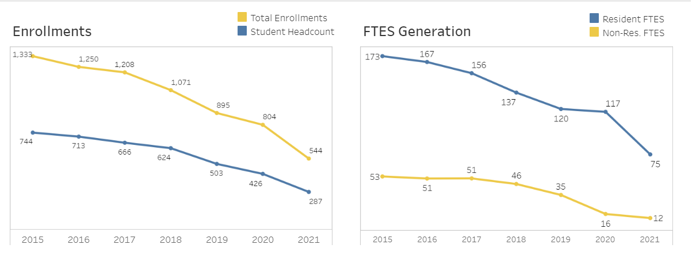

ESL Course Success Latinx Students (Disaggregated by Gender)
Source: Tableau
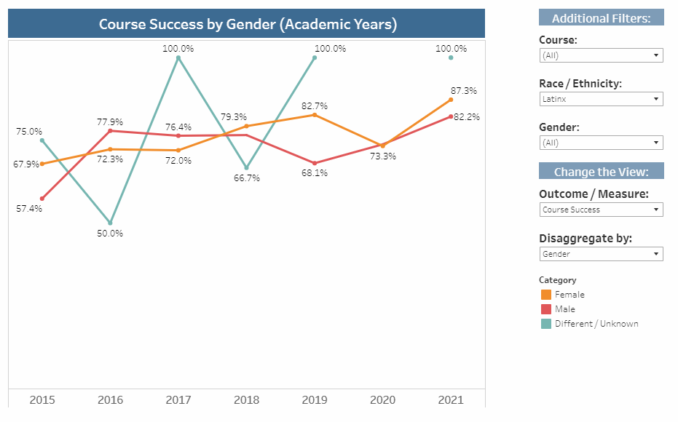

ESL Course Success Asian Students (Disaggregated by Gender)
Source: Tableau
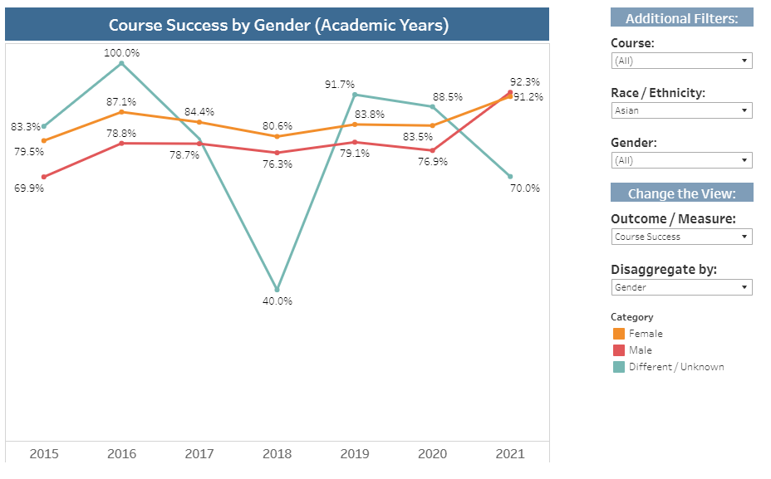

Transfer Level Completion Rates in ESL (3-year timeframe) for Colleges in Orange County (2019-2020)
Source: https://www.cccco.edu/About-Us/Chancellors-Office/Divisions/Educational-Services-and-Support/transfer-level-dashboard
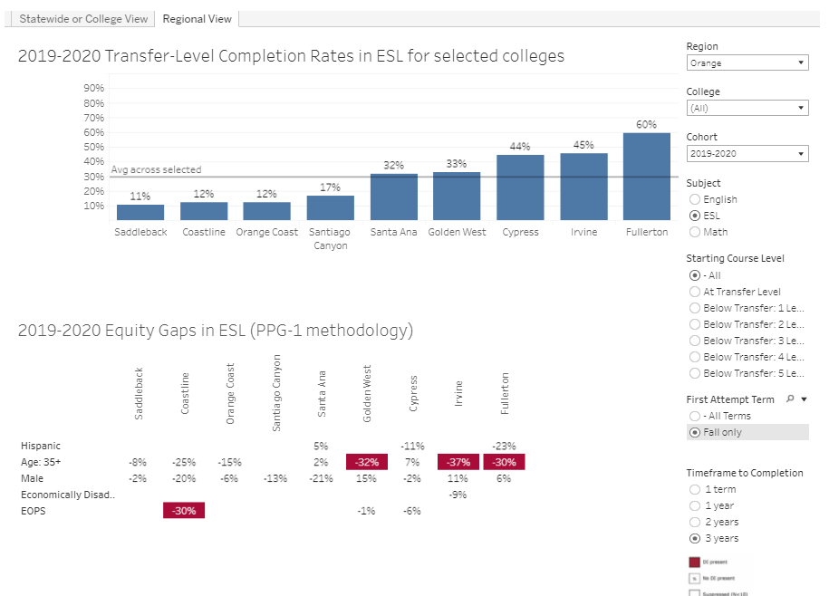

Transfer Level Completion Rates in ESL (3-year timeframe) for Colleges in Orange County (2018-2019)
Source: https://www.cccco.edu/About-Us/Chancellors-Office/Divisions/Educational-Services-and-Support/transfer-level-dashboard

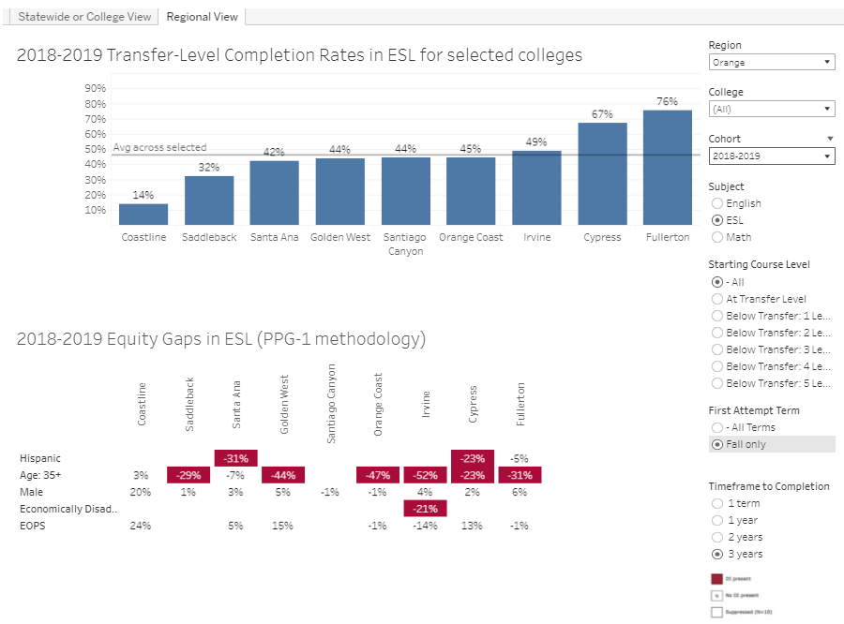
Transfer Level Completion Rates in ESL (3-year timeframe) for Colleges in Orange County (2017-2018)
Source: https://www.cccco.edu/About-Us/Chancellors-Office/Divisions/Educational-Services-and-Support/transfer-level-dashboard

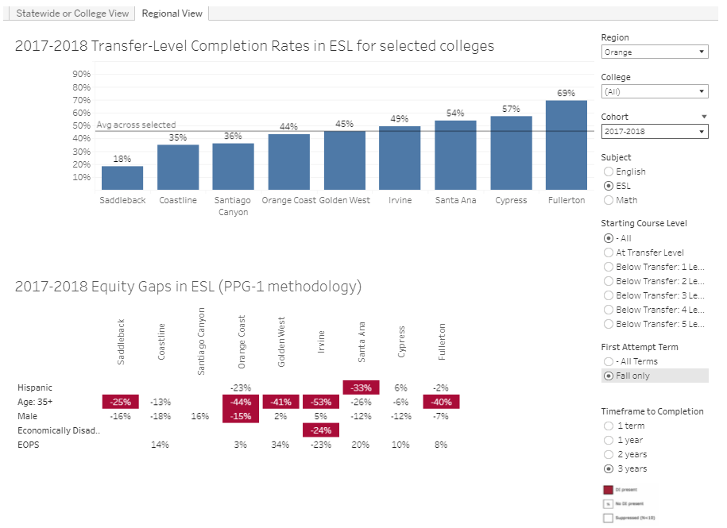

Annual Refugee Resettlement Ceiling and Number of Refugees Admitted to the United States
Source: https://www.migrationpolicy.org/article/refugees-and-asylees-united-states-2021
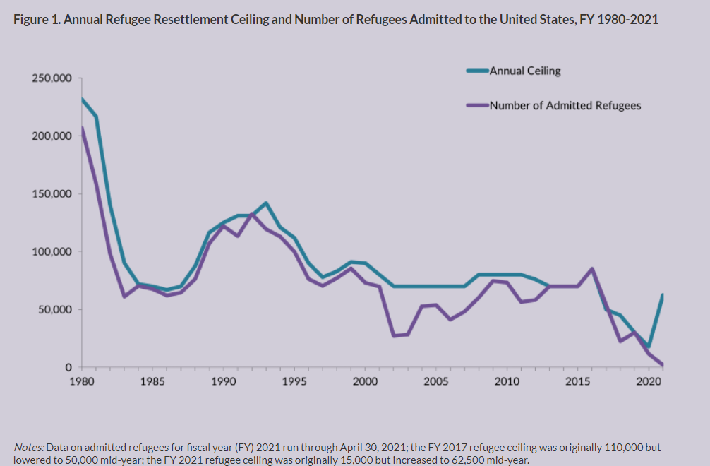

ESL Enrollment Headcount (Asian)
Source: Tableau
