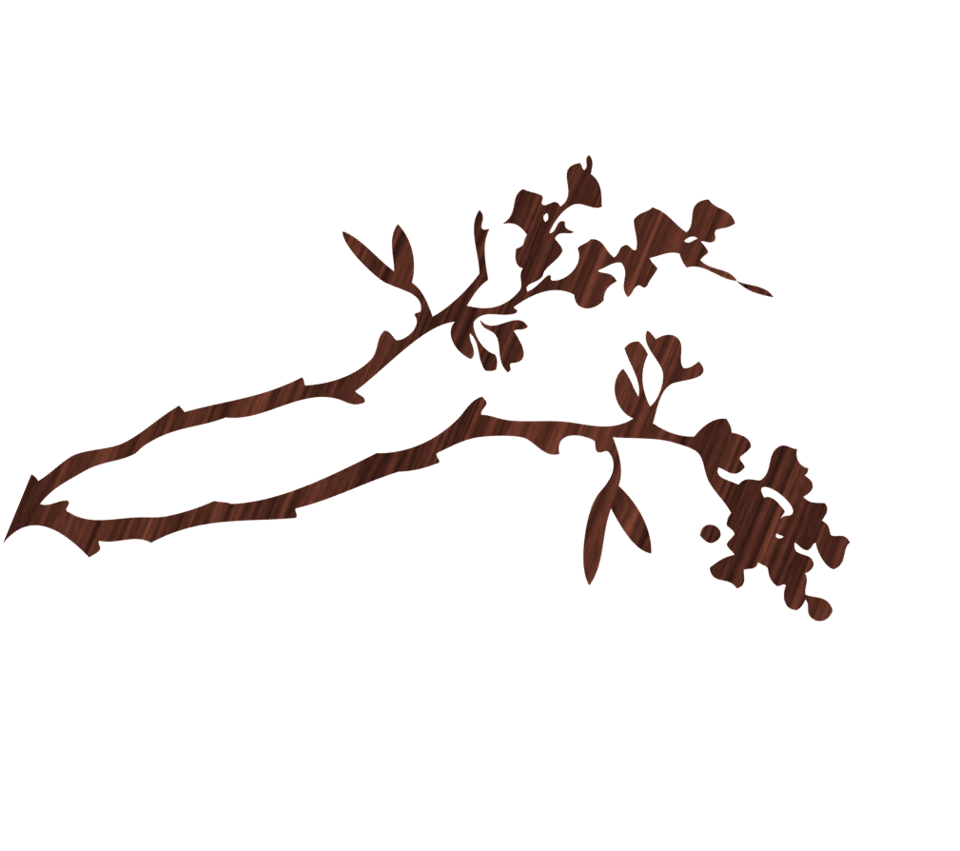
Program Review committee
for information contact: Kelly Robertson, PRC Interim Chair @ 714-992-7592
meeting schedule

fall 2017
2nd & 4th Thursday’s of the Month

Thursday’s
September 14th & 28th
October 12th & 26th
November 9th & 30 (Note: Thanksgiving Holiday Nov. 23rd)

Time: 3:00-4:30pm
Location: Room 227 Conference Room

